Bash Scripting Video Executions – Day 1
Launch New Instance
Step 1: Launch AWS EC2 Instance
- Open AWS Console
- Go to EC2 Dashboard
- Click Launch Instance
- Choose Amazon Linux
- Create/Select key pair
- Launch instance

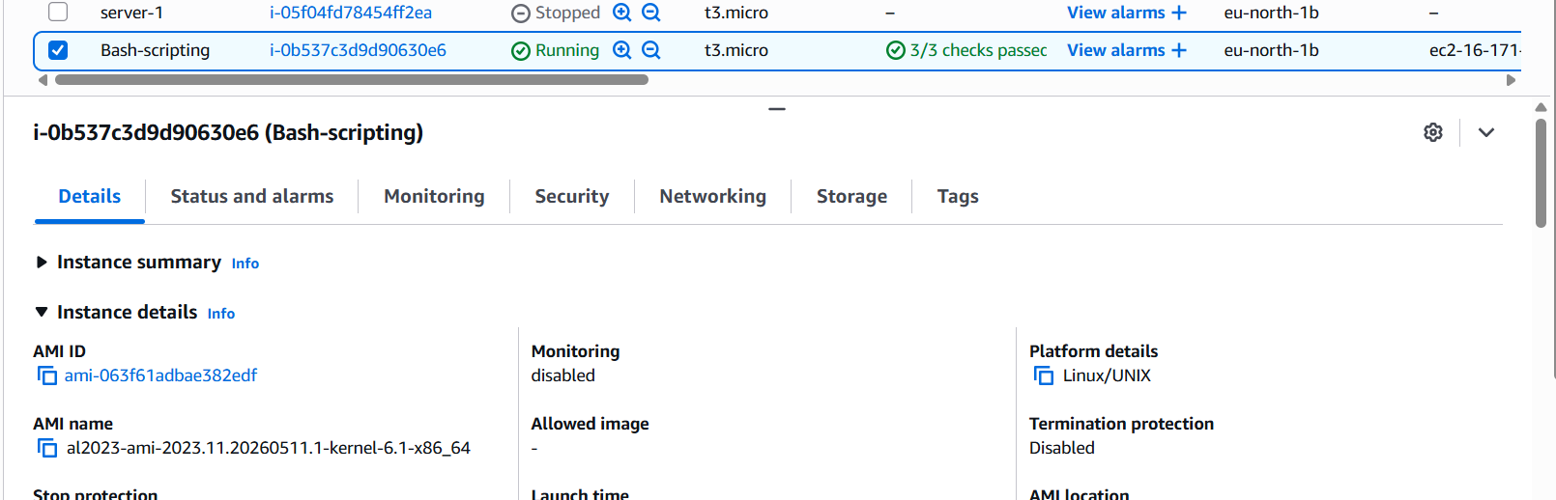

Step 2: Connect to Instance
ssh -i mykey.pem ec2-user@Public-IP
Move to root:
sudo -i
Validation:
whoami
Expected Output:
root
Screenshot Evidence: Mandatory

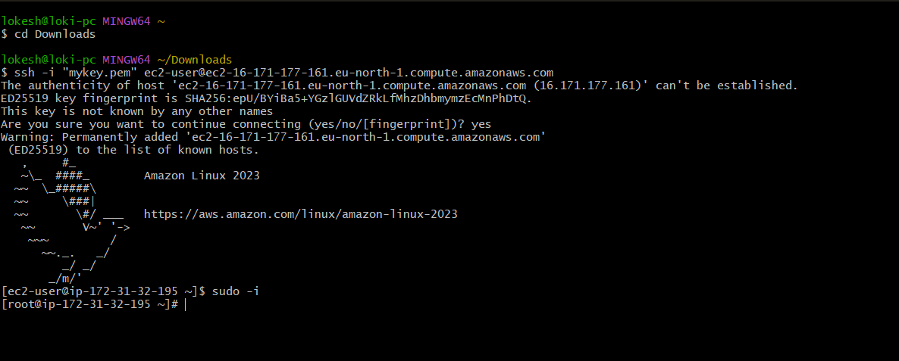
tep 3: Check Current Shell
echo $0
Expected:
-bash
Explanation: Displays currently active shell

Step 4: Check Installed Shells
cat /etc/shells
Step 5: Check User Assigned Shell
ask 2: Hello World Script
Outcome:-
Successfully created and executed first shell script.
Objective:-
Understand basic Bash script structure.
Create Script
vi helloworld.bash
Add:
#!/bin/bash
echo "Hello World"
Save:
:wq
Permission:
chmod 755 helloworld.bash
Execute:
./helloworld.bash
Output:

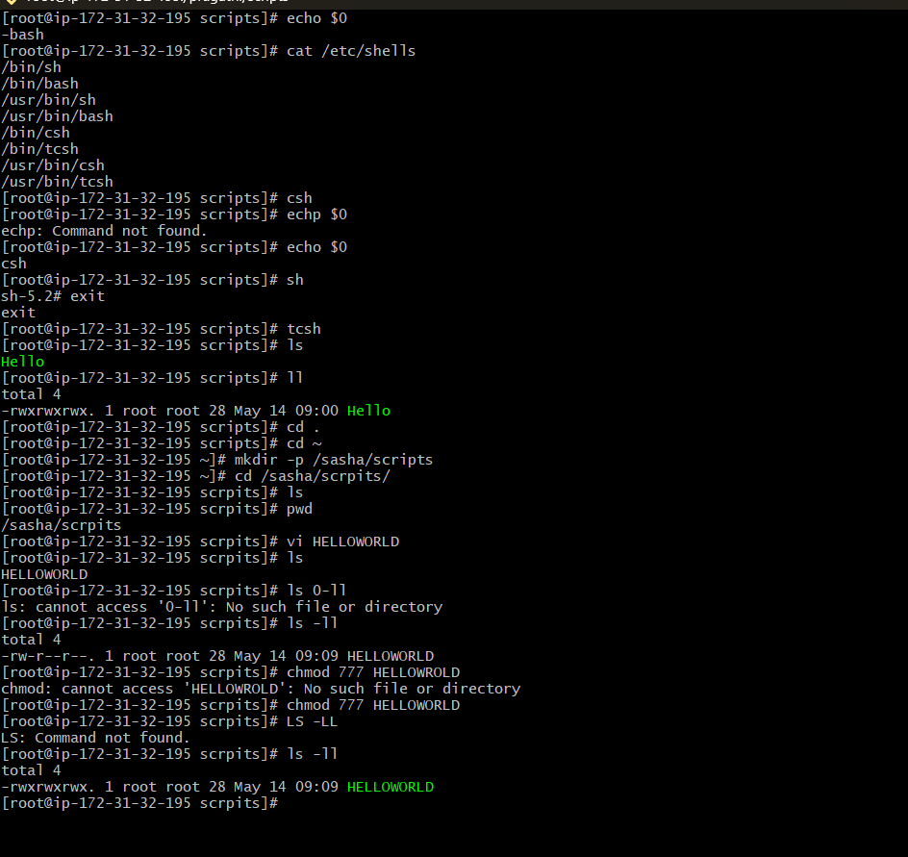
Task 1: Create a Basic Shell Script – Hello World
Outcome:- Successfully created and executed a basic shell script that prints “Hello World” as output.
Objective:- The objective of this task is to understand the basic structure of a shell script and learn how to execute commands using Bash scripting.
Prerequisites:- Before starting this task, the following requirements were needed:
- Linux system access
- Bash shell availability
- Basic knowledge of terminal commands
- Text editor such as vi
Step-by-Step Implementation:-
In this task, a basic shell script was created using the Bash shell. First, a new file named helloworld.bash was created using a text editor. Inside the script, the shebang line #!/bin/bash was added to define the shell interpreter. Then the echo command was used to print the message “Hello World”.
Script Used
#!/bin/bash
echo "Hello World"
After saving the file, executable permissions were assigned using the chmod command.
Permission Command
chmod 755 hello.sh
The script was then executed using the following command:
./helloworld.bash
The output displayed the message “Hello World!” successfully.
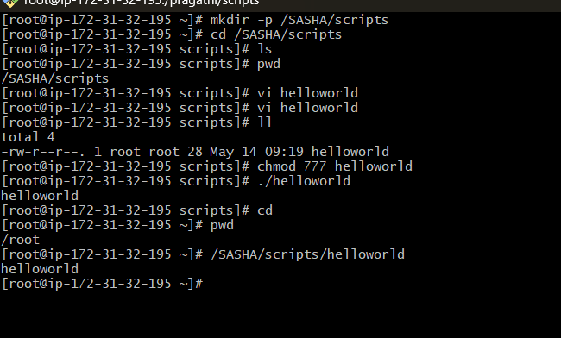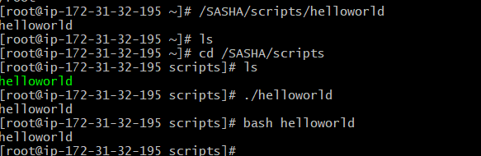

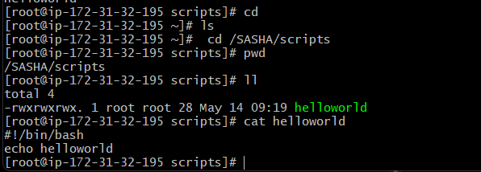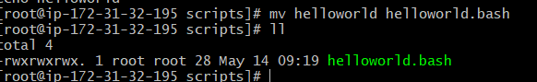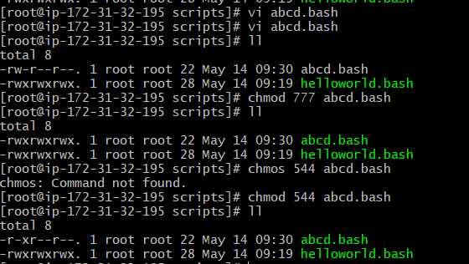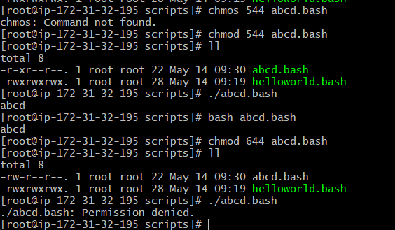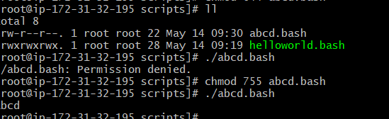

Define variables:
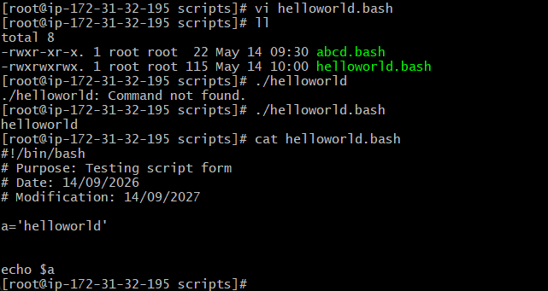
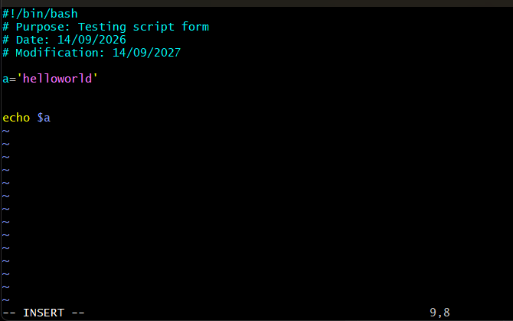

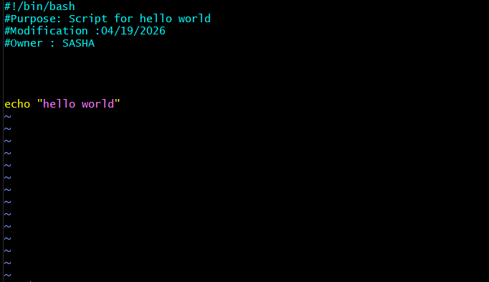

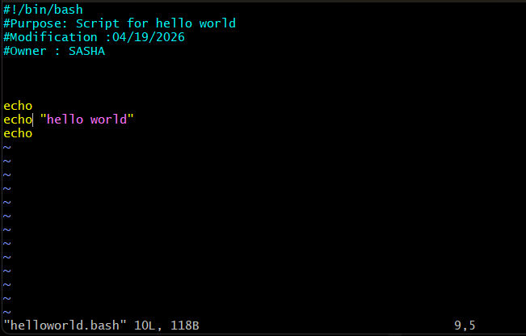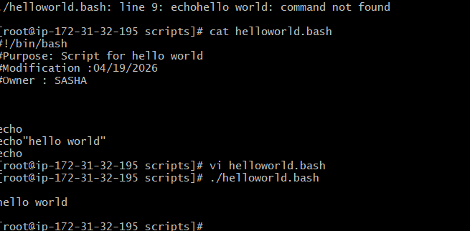

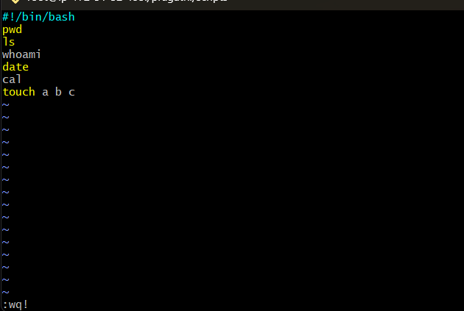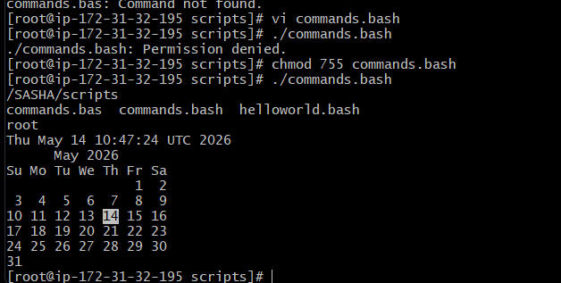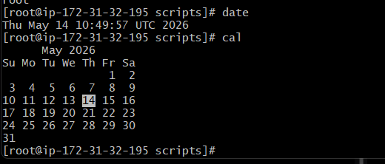

-------
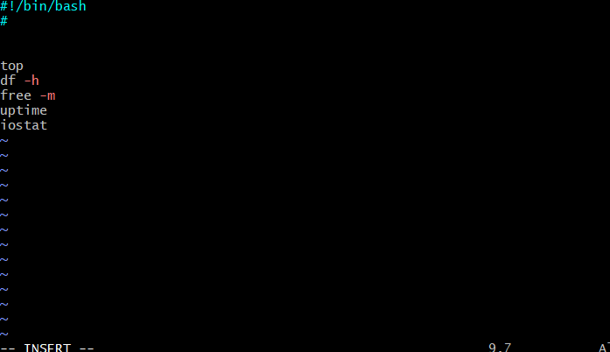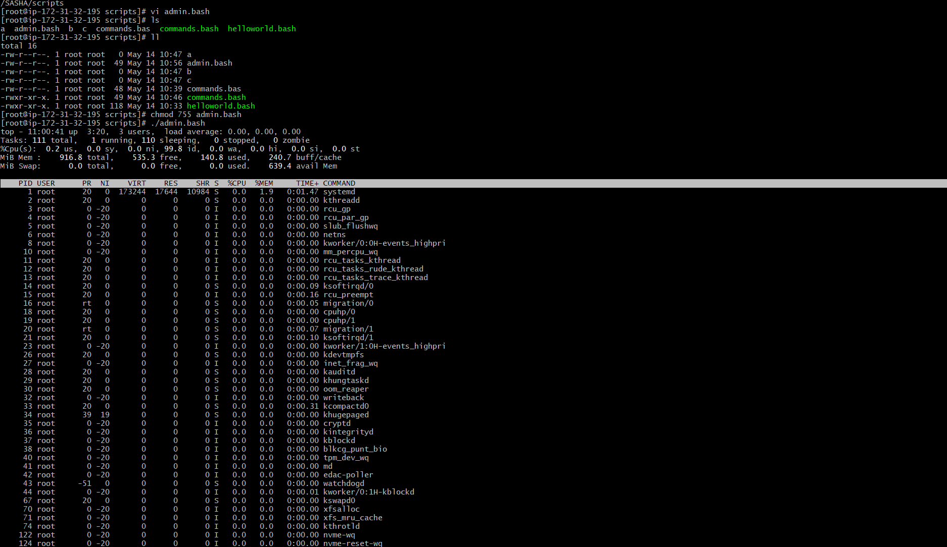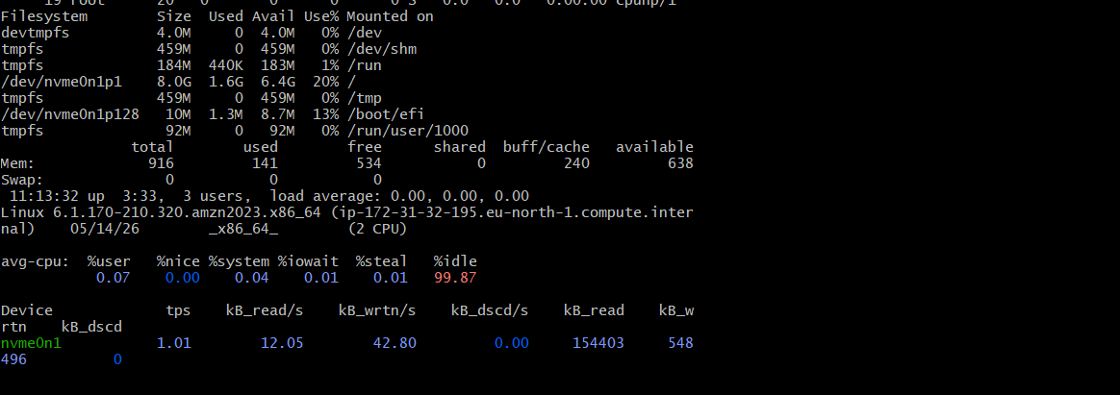
When we use head-10
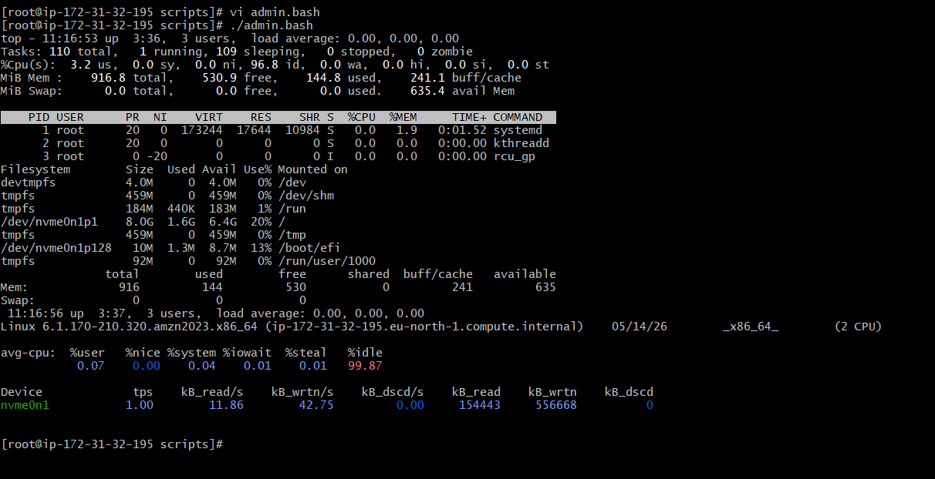

Variables:
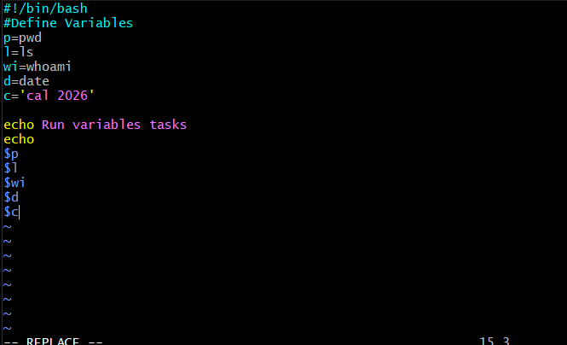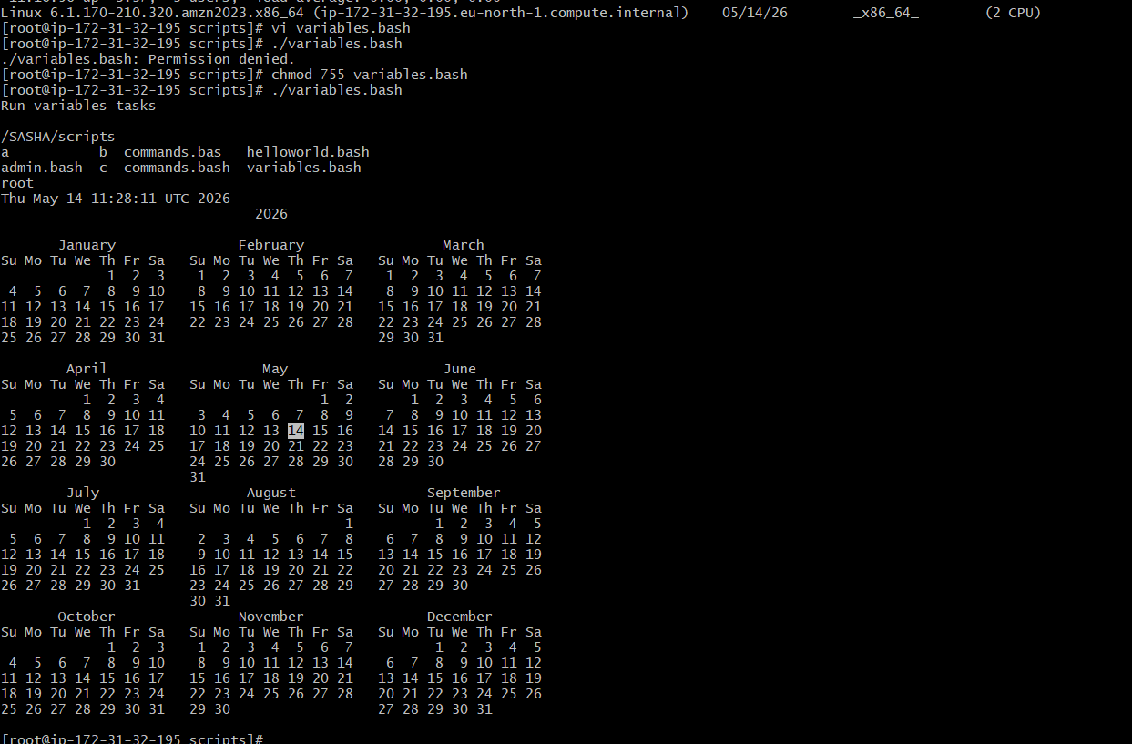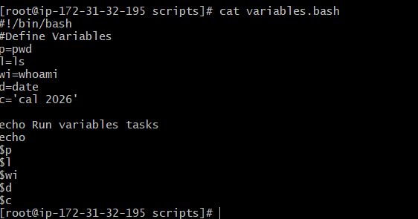

Input and ouput script:
Ex1:
#!/bin/bash
echo Hello, my name is Sasha
echo
echo what is your name?
read name
echo
echo Hello $name
echo

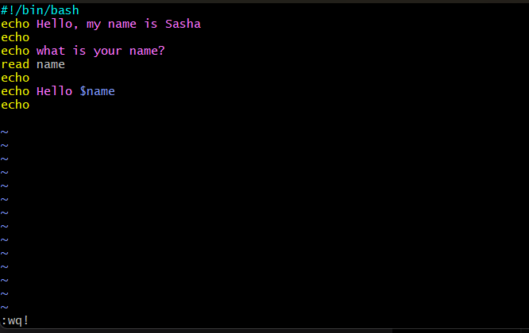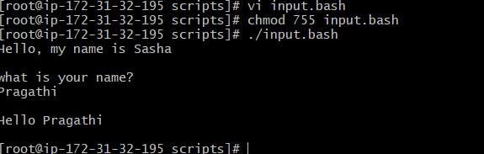

Ex2:
#!/bin/bash

#we need to use the ticks if you want to use this in echo or else not required
a=`hostname`
echo Hello, my name is $a
echo
echo what is your name?
read b
echo
echo Hello $b
echo
